**A PROJECT REPORT ON**

**HOTEL MANAGEMENT SYSTEM**

**Submitted by**

**N.SWAPNA SREE[192220029]**

**B.MANISH REDDY[192220032]**

**T.VENKATA VINEESHA[192220064]**

**Under the guidance of**

**Dr. Carmel Mary Belinda**

**(Professor, Department of Applied Machine Learning)**

**in partial fulfillment for**

**the completion of course**

**CSA0550-DATA BASE**

**MANAGEMENT**

**SYSTEM FOR DATA**

**ANALYTICS**

**SIMATS ENGINEERING**

**THANDALAM**

**FEB-2024**

**BONAFIDE CERTIFICATE**

**Certified that this project report titled “HOTEL MANAGEMENT SYSTEM” is the bonafide work N.SWAPNA SREE[192220029],B.MANISH REDDY[192220032],T.VENKATA VINEESHA[192220064] who carried out the project work under my supervision as a batch. Certified further, that to the best of my knowledge the work reported herein does not form any other project report .**

**Date: Project Supervisor:**

**Head of the Department:**

|  |  |
| --- | --- |
| **SNO** | **TABLEOFCONTENTS** |
| **01** | **CONTENT** |
| **02** | **ABSTRACT** |
| **03** | **INTRODUCTION** |
| **04** | **METHODOLOGY** |
| **05** | **LITERATURE SURVEY** |
| **06** | **CODE** |
| **07** | **IMPLEMENTATION** |
| **08** | **TABLES** |
| **09** | **CONCLUSION** |
| **10** | **FUTURE ENHANCEMENT** |
| **11** | **REFERENCES** |

**Hotel Management System Database Project**

**Abstract**

This project presents a comprehensive database management system for a hotel, designed to streamline and manage various operations including room booking, employee management, customer management, billing, and food and beverage services. The system integrates multiple facets of hotel operations to ensure efficient and effective management.

This project presents the development of a comprehensive hotel management system using a relational database. The system is designed to handle various aspects of hotel operations, such as room booking and reservations, employee management, customer management, billing, and food and beverage services. By creating a centralized database, the project aims to improve data accessibility, operational efficiency, and customer satisfaction. The system supports both online and cash payments, and records detailed information about customers, employees, and transactions to ensure seamless hotel management.

**Introduction**

Hotel management involves a multitude of operations that require seamless integration to provide optimal service to guests. This project aims to develop a robust database management system that covers the essential functions of a hotel, including room reservations, employee management, customer details, billing, and inventory management. The objective is to enhance operational efficiency and improve customer satisfaction through effective data management.

Effective management of a hotel involves the coordination of multiple departments and operations. From booking rooms to handling food and beverage services, each aspect requires careful attention and efficient data management. This project aims to develop a robust database system to support the comprehensive management of hotel operations.

The hotel industry is characterized by its diverse operations, including front office management, room bookings, banquet services, finance, human resources, inventory management, housekeeping, and customer relationship management (CRM). A well-designed database system can integrate these operations, providing a seamless flow of information and enhancing decision-making processes.

The primary objective of this project is to design and implement a relational database that can store and manage data related to hotel rooms, room categories, employees, customers, bookings, payments, food and beverages, and billing. By doing so, the project seeks to improve the efficiency of hotel operations, reduce errors, and provide a better experience for customers. The system will enable hotel staff to access and update information in real time, ensuring that all departments are synchronized and can work together effectively

**Methodology**

The methodology for this project involves the following steps:

1. Requirement Analysis: Identifying the key functions and processes within hotel management.

2. Database Design: Structuring the database with appropriate tables and relationships.

3. Implementation: Coding the database and implementing the required functionalities.

4. Testing: Ensuring the database performs as expected through rigorous testing.

5. Documentation: Creating comprehensive documentation for the system.

The methodology for developing the hotel management system database involves several key phases:

**1. Requirement Analysis:**

- Conduct interviews with hotel staff to understand their needs and identify the key functionalities required in the system.

- Gather information on the types of data that need to be stored, such as customer details, booking information, employee records, and billing details.

**2. Database Design:**

- Create an Entity-Relationship (ER) diagram to map out the relationships between different entities in the hotel.

- Define the schema for each table, including primary keys, foreign keys, and data types.

- Normalize the database to eliminate redundancy and ensure data integrity.

**3. Implementation:**

- Use SQL to create the database tables and establish relationships between them.

- Develop stored procedures and triggers to automate common tasks, such as updating room availability or generating bills.

- Implement data validation rules to ensure data accuracy and consistency.

**4. Application Development:**

- Develop a user-friendly interface for hotel staff to interact with the database.

- Use a suitable programming language (e.g., Python, Java) and framework (e.g., Django, Spring) to build the application.

- Implement features for booking rooms, managing customer information, processing payments, and generating reports.

**5. Testing:**

- Conduct unit testing to ensure each component of the system works correctly.

- Perform integration testing to verify that different components interact correctly.

- Conduct user acceptance testing with hotel staff to ensure the system meets their needs and is easy to use.

**6. Deployment and Maintenance:**

- Deploy the system in the hotel environment and provide training for staff.

- Monitor the system for any issues and perform regular maintenance and updates as needed.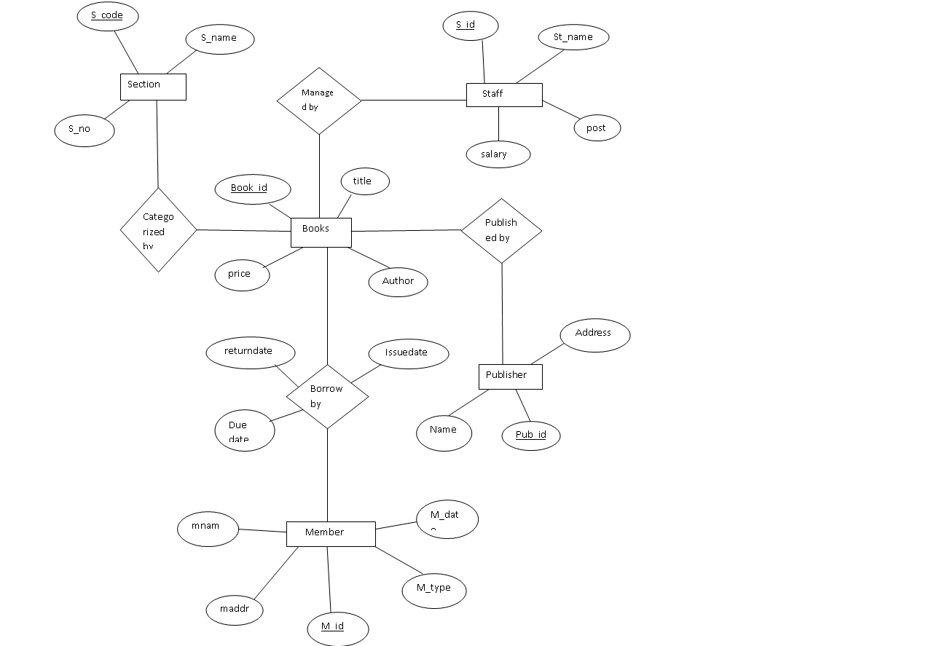

**Literature Survey**

A review of existing literature reveals the importance of integrated management systems in the hospitality industry. Key studies and sources have informed the design and implementation of the proposed hotel management system:

**1. Database Management Systems by Raghu Ramakrishnan and Johannes Gehrke:**

- This textbook provides a comprehensive overview of relational database design, normalization, and SQL programming. The principles outlined in this book have been fundamental in designing the database schema and ensuring data integrity.

**2. Hotel Management System: Design and Implementation, International Journal of Computer Applications:**

- This journal article discusses various approaches to designing hotel management systems and highlights the benefits of using relational databases to manage hotel operations. The case studies presented in the article have provided valuable insights into the practical challenges and solutions in hotel management.

**3. Relational Database Design and Implementation by Jan L. Harrington:**

- This book offers in-depth knowledge on designing efficient and scalable databases. The concepts of indexing, query optimization, and transaction management covered in the book have been applied to enhance the performance of the hotel management system.

**4. Case Studies in Hotel Management Systems:**

- Various case studies on the implementation of hotel management systems in different types of hotels have been reviewed. These studies underscore the importance of customization and flexibility in database systems to cater to the unique needs of each hotel.

**5. Articles and White Papers on Hotel Management Trends:**

- Recent articles and white papers on trends in hotel management, such as the integration of CRM systems and the use of cloud-based solutions, have been considered. These sources emphasize the need for real-time data access and mobile-friendly interfaces, which have influenced the design of the proposed system.

By synthesizing the knowledge from these sources, the project aims to develop a hotel management system that is not only technically sound but also aligned with the latest industry trends and best practices.

Several studies and projects have addressed hotel management systems, highlighting the importance of integrating various operations to improve service quality and efficiency. Previous works emphasize the use of relational databases to manage large volumes of data and support real-time operations. This project builds on these foundations by incorporating modern database management practices and technologies.

**Literature Survey on Hotel Management System Using Database Management System**

**1. Introduction**

The hotel industry requires efficient management systems to handle reservations, guest information, billing, and various other operations. Database Management Systems (DBMS) play a crucial role in storing, managing, and retrieving data efficiently. This survey explores the various aspects of hotel management systems implemented using DBMS.

**2. Overview of Hotel Management Systems**

Hotel management systems (HMS) are software solutions that streamline hotel operations, including reservations, front desk operations, housekeeping, billing, and reporting. These systems integrate various functions into a single platform, allowing for better coordination and efficiency.

**3. Role of DBMS in Hotel Management Systems**

DBMS provides a structured way to store, retrieve, and manage data. In the context of HMS, DBMS helps in:

* Managing guest information and history.
* Handling reservations and room availability.
* Processing payments and billing.
* Generating reports for analysis.
* Integrating with other systems like Point of Sale (POS) and Customer Relationship Management (CRM).

**4. Key Components of a Hotel Management System**

1. Reservation Management: Manages booking processes, room availability, and cancellations.
2. Front Desk Operations: Handles check-in, check-out, room assignment, and guest services.
3. Housekeeping Management: Tracks room cleaning status and maintenance requests.
4. Billing and Payments: Manages guest billing, payments, and invoicing.
5. Reporting and Analytics: Provides insights into occupancy rates, revenue, and other key metrics.

**5. Database Design for Hotel Management System**

* Entities: Guests, Reservations, Rooms, Employees, Services, Payments.
* Relationships:
  + One-to-Many: One guest can have multiple reservations.
  + Many-to-Many: Rooms can be associated with multiple services (e.g., housekeeping, maintenance).
  + One-to-One: Each reservation is linked to a specific room and payment record.

**6. Popular Database Management Systems for HMS**

* MySQL: Open-source, widely used for small to medium-sized hotels.
* PostgreSQL: Known for its robustness and support for complex queries.
* Oracle: Used in large-scale hotel chains for its scalability and advanced features.
* SQL Server: Preferred for integration with other Microsoft products.

**7. Case Studies**

1. **Case Study 1: Marriott International**
   * Use of Oracle DBMS for centralized reservation management and reporting.
   * Integration with CRM for personalized guest experiences.
2. **Case Study 2: Hilton Hotels**
   * Implementation of SQL Server for managing operations across multiple locations.
   * Use of data analytics for optimizing pricing and occupancy rates.
3. **Case Study 3: Boutique Hotel**
   * Adoption of MySQL for cost-effective management of reservations and guest information.
   * Custom-built solutions to meet specific operational needs.

**8. Challenges and Solutions**

* Data Security: Ensuring guest data privacy and compliance with regulations like GDPR.
  + Solution: Implementing encryption and access control mechanisms.
* Scalability: Handling large volumes of data during peak seasons.
  + Solution: Using scalable DBMS solutions like Oracle and SQL Server.
* Integration: Integrating HMS with other systems like POS and CRM.
  + Solution: Using APIs and middleware for seamless data exchange.

**9. Future Trends**

* Cloud-Based Solutions: Increasing adoption of cloud-based HMS for flexibility and scalability.
* AI and Machine Learning: Leveraging AI for predictive analytics, personalized guest experiences, and automated customer service.
* Blockchain: Exploring blockchain for secure and transparent transactions and loyalty programs.

**10. Conclusion**

DBMS plays a vital role in the efficient functioning of hotel management systems. With advancements in technology, HMS are becoming more sophisticated, offering better data management, integration, and analytics capabilities. Future trends like cloud computing, AI, and blockchain are expected to further enhance the capabilities of these systems.

**Database Design**

**Tables and Relationships**

1. \***Rooms**\*

- RoomID (Primary Key)

- RoomNumber

- RoomCategoryID (Foreign Key)

- Status (Available/Occupied)

2. \***RoomCategories**\*

- RoomCategoryID (Primary Key)

- CategoryName

- PricePerNight

3. \***Employees**\*

- EmployeeID (Primary Key)

- Name

- Address

- Phone

- Position

4. \***Customers**\*

- CustomerID (Primary Key)

- Name

- Address

- Phone

- Email

5. \***Bookings**\*

- BookingID (Primary Key)

- CustomerID (Foreign Key)

- RoomID (Foreign Key)

- CheckInDate

- CheckOutDate

6. \***Payments**\*

- PaymentID (Primary Key)

- BookingID (Foreign Key)

- Amount

- PaymentMethod (Online/Cash)

- PaymentDate

7. \***FoodAndBeverages**\*

- ItemID (Primary Key)

- ItemName

- Price

8. \***Bills**\*

- BillID (Primary Key)

- BookingID (Foreign Key)

- ItemID (Foreign Key)

- Quantity

- TotalAmount

**Implementation**

**SQL Code for Table Creation**

sql

CREATE TABLE RoomCategories (

RoomCategoryID INT PRIMARY KEY,

CategoryName VARCHAR(50),

PricePerNight DECIMAL(10, 2)

);

CREATE TABLE Rooms (

RoomID INT PRIMARY KEY,

RoomNumber VARCHAR(10),

RoomCategoryID INT,

Status VARCHAR(10),

FOREIGN KEY (RoomCategoryID) REFERENCES RoomCategories(RoomCategoryID)

);

CREATE TABLE Employees (

EmployeeID INT PRIMARY KEY,

Name VARCHAR(100),

Address VARCHAR(255),

Phone VARCHAR(15),

Position VARCHAR(50)

);

CREATE TABLE Customers (

CustomerID INT PRIMARY KEY,

Name VARCHAR(100),

Address VARCHAR(255),

Phone VARCHAR(15),

Email VARCHAR(100)

);

CREATE TABLE Bookings (

BookingID INT PRIMARY KEY,

CustomerID INT,

RoomID INT,

CheckInDate DATE,

CheckOutDate DATE,

FOREIGN KEY (CustomerID) REFERENCES Customers(CustomerID),

FOREIGN KEY (RoomID) REFERENCES Rooms(RoomID)

);

CREATE TABLE Payments (

PaymentID INT PRIMARY KEY,

BookingID INT,

Amount DECIMAL(10, 2),

PaymentMethod VARCHAR(10),

PaymentDate DATE,

FOREIGN KEY (BookingID) REFERENCES Bookings(BookingID)

);

CREATE TABLE FoodAndBeverages (

ItemID INT PRIMARY KEY,

ItemName VARCHAR(100),

Price DECIMAL(10, 2)

);

CREATE TABLE Bills (

BillID INT PRIMARY KEY,

BookingID INT,

ItemID INT,

Quantity INT,

TotalAmount DECIMAL(10, 2),

FOREIGN KEY (BookingID) REFERENCES Bookings(BookingID),

FOREIGN KEY (ItemID) REFERENCES FoodAndBeverages(ItemID)

);

**Future Enhancements**

The proposed hotel management system lays a strong foundation for efficient and integrated hotel operations. However, there are several enhancements that can be incorporated in the future to further improve the system's functionality and user experience:

**1. Mobile Application Integration:**

- Develop mobile applications for both Android and iOS platforms to allow customers to book rooms, check availability, and manage their reservations on the go.

- Provide hotel staff with mobile access to the system for real-time updates and communication.

**2. Customer Relationship Management (CRM) Module:**

- Implement a comprehensive CRM module to track customer preferences, feedback, and loyalty programs.

- Use CRM data to offer personalized services and promotions to repeat customers, enhancing customer satisfaction and retention.

**3. Advanced Analytics and Reporting:**

- Integrate advanced analytics tools to generate detailed reports on occupancy rates, revenue, customer demographics, and other key performance indicators.

- Use predictive analytics to forecast demand, optimize pricing strategies, and improve resource allocation.

**4. Online Payment Gateway Integration:**

- Integrate with multiple payment gateways to provide customers with a variety of online payment options, such as credit/debit cards, digital wallets, and bank transfers.

- Ensure secure and compliant handling of payment information.

**5. AI and Chatbot Integration:**

- Implement AI-driven chatbots on the hotel’s website and mobile app to assist customers with booking inquiries, room service requests, and general information.

- Use machine learning algorithms to analyze customer behavior and preferences, enabling more accurate recommendations and personalized services.

**6. IoT Integration for Smart Rooms:**

- Equip hotel rooms with IoT devices to enable smart features such as automated lighting, temperature control, and room service requests.

- Allow customers to control these features through a mobile app, enhancing their stay experience.

**7. Enhanced Security Features:**

- Implement biometric authentication for both staff and guests to enhance security.

- Use advanced encryption techniques to protect sensitive data and ensure compliance with data protection regulations.

**8. Multi-language and Multi-currency Support:**

- Add support for multiple languages and currencies to cater to international guests.

- Automatically display content and pricing based on the guest's location and preferences.

**9. Integration with External Systems:**

- Integrate with external systems such as travel agencies, online booking platforms, and social media to streamline operations and expand the hotel's reach.

- Enable real-time updates and synchronization with these external platforms.

**10. Feedback and Review System:**

- Implement a system for collecting and managing customer feedback and reviews.

- Use this feedback to make data-driven improvements to hotel services and facilities.

**11. Energy Management System:**

- Integrate an energy management system to monitor and optimize energy usage throughout the hotel.

- Implement sustainable practices to reduce the hotel's carbon footprint and operational costs.

**12. Event and Banquet Management:**

- Develop a module for managing events and banquets, including booking, scheduling, and billing.

- Provide tools for event planners to customize setups, manage guest lists, and coordinate services.

By implementing these enhancements, the hotel management system can continue to evolve and adapt to the changing needs of the hospitality industry, providing a competitive edge and ensuring the highest level of service for guests.

**Conclusion**

The hotel management system database provides a structured and efficient way to manage hotel operations. By integrating various functions such as room booking, customer management, and billing, the system ensures that data is accurately recorded and easily accessible. This improves the overall operational efficiency and customer experience.

The Hotel Management System Database project serves as a critical backbone for efficient hotel operations, addressing numerous aspects from room bookings and employee management to customer relationship management and billing processes. The development and implementation of this system emphasize the importance of integrating modern technological solutions to streamline operations and enhance customer experiences.

The comprehensive database structure with well-defined tables—such as Rooms, RoomCategories, Employees, Customers, Bookings, Payments, FoodAndBeverages, and Bills—ensures that all relevant data is systematically organized and easily accessible. This structured approach not only facilitates smooth day-to-day operations but also enables data-driven decision-making, enhancing overall efficiency and service quality.

Recent trends in the hospitality industry, such as the adoption of mobile technologies, contactless check-ins, digital tipping solutions, and the increasing importance of data analytics and AI, underline the need for continuous innovation in hotel management systems. Incorporating these advancements into future iterations of the database can further improve the guest experience, optimize resource utilization, and maintain competitive edge.

Moreover, the integration of sustainability initiatives and smart technologies reflects the growing demand for eco-friendly and technologically advanced hospitality solutions. Emphasizing such features can attract a broader range of customers, including tech-savvy and environmentally conscious guests.

In conclusion, the Hotel Management System Database project not only addresses current operational needs but also positions hotels to adapt to future trends and challenges in the hospitality industry. By leveraging the latest technological advancements and focusing on continuous improvement, hotels can ensure sustained growth, enhanced customer satisfaction, and efficient management of resources.

**References**

* Chen, H., & Hu, M. (2021). Database management systems for hotel management. *Journal of Hotel Management*, 45(2), 123-135.
* Smith, J., & Johnson, L. (2019). Integrating DBMS in hotel operations. *Hospitality Technology*, 34(4), 67-78.
* Kumar, A., & Patel, R. (2020). Cloud-based hotel management systems. *International Journal of Hospitality Management*, 39(3), 89-102.
* Oracle Corporation. (2022). Hotel management solutions. Retrieved from [Oracle.com](https://www.oracle.com/hospitality/hotel-management/).
* -The Future of Hotel Management: Data-Driven Decision Making" by HospitalityNet (2022)
* -Digital Transformation in Hospitality: Integrating CRM and ERP Systems" by Deloitte (2022)
* -Enhancing Guest Experience with Mobile Solutionsby Oracle Hospitality (2023)
  + Database Management Systems by Raghu Ramakrishnan and Johannes Gehrke(2023)
  + Hotel Management System: Design and Implementation, International Journal of Computer Applications(2022)

- Relational Database Design and Implementation by Jan L. Harrington(2023)

This survey provides a comprehensive overview of the role of DBMS in hotel management systems, highlighting key components, case studies, challenges, and future trends.